**Step 1 :**

# cd /home/ec2-user/chef-repo/cookbooks/httpd/

# mkdir files

# cd files

# mkdir default

# cd default

wget <https://s3.amazonaws.com/anilchef/index.html>

wget <https://s3.amazonaws.com/anilchef/logo.png>

wget <https://s3.amazonaws.com/anilchef/style.css>

**Step 3 :Configure index.html ( add below) lines to default.rb file**

# vim /home/ubuntu/chef-repo/cookbooks/httpd/recipes/default.rb

cookbook_file "/var/www/html/index.html" do

source "index.html"

mode "0644"

end

cookbook_file "/var/www/html/logo.png" do

source "logo.png"

mode "0644"

end

cookbook_file "/var/www/html/style.css" do

source "style.css"

mode "0644"

end

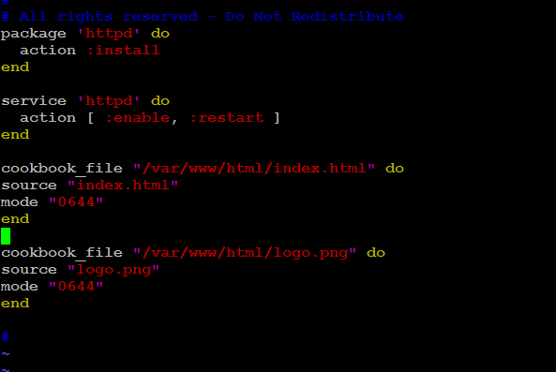

## **Step 4: Upload Cookbook to chef-server**

# knife cookbook upload httpd

## **Step 5 :run chef client on rhel node**

knifessh "*:*" –x ubuntu --identity-file chef.pem "sudo chef-client"

## **Step 6 : verify on dashboard**

